**Experiment 1** **:-** Design an LED Flasher

**Circuit Diagram:-**

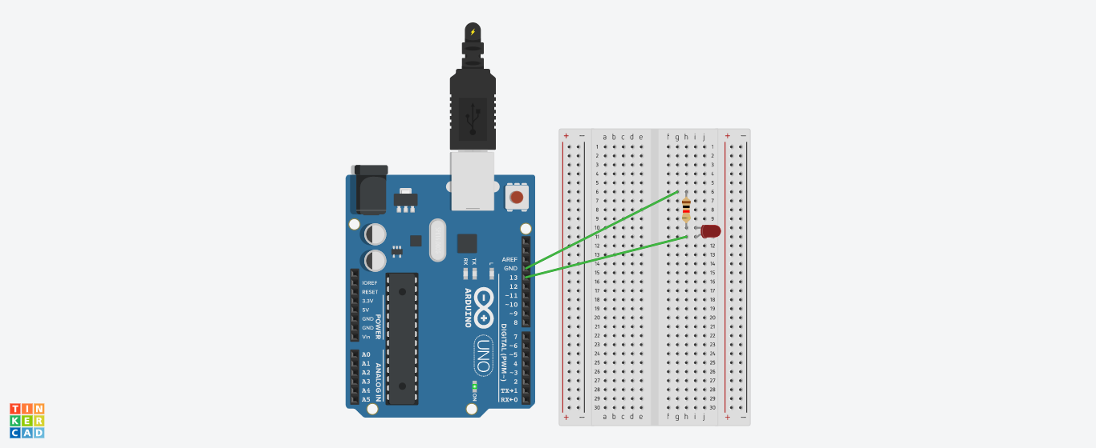

**Theory:**

**Concept Used:**

The concept used for the realization and implementation of the above task is that when an LED(Light emitting diode) is powered by the Arduino (Power source) it glows and when the power supply is switched off the LED stops glowing. This cycle starts over again and the process of ON and OFF continues. But this process occurs too fast that our eye cannot realize it so a time delay needs to be introduced. Time delay holds the condition for a particular time and thus facilitates observation.

* **OHM’s Law:** Ohm’s law states that the current through a conductor between two points is directly proportional to the voltage across two points provided that the temperature remains constant.

V=IR

This is used to determine the value of the resistor suitable for the

circuit thus preventing the LED from burning out.

* **Breadboard**

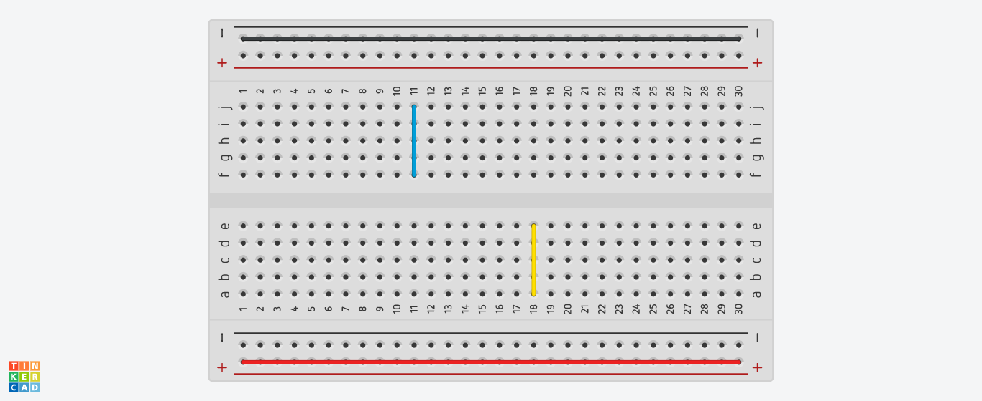

The lines with different colors above show the way in which the holes are connected to each other.

* The digital pins (i.e 0-13) are at high potential(5V) and the GND (Ground) pin is at zero potential.

**Learning & Observations:** Ilearnedthe basics of an Arduino Board, how it works and what are its various components. I also learned how to code an Arduino and use it to make an LED work as a flasher. The observation made was that the LED starts blinking after uploading the code to the Arduino.

**Problems & Troubleshooting:** The setting up of the circuit on the breadboard was a challenging task while which one needs to be very careful. At first the LED pin was not inserted properly due to which the LED was not working. After encountering the error the circuit was fixed and the desired result was achieved.

**Precautions:**

* The wires and pins should be inserted properly.
* The LED should be checked using a Multimeter before use.
* The wires should also be checked for continuity before use.
* The anode should be connected to the power supply and cathode to the ground.
* The LED should be connected to a resistor to prevent it from any damage.

**Learning Outcomes:** I learned the basics of arduino and about it’s various components. I learned how to realize a circuit using Arduino and also how to code Arduino to get the desired output. I also learned how to make a circuit on breadboard.